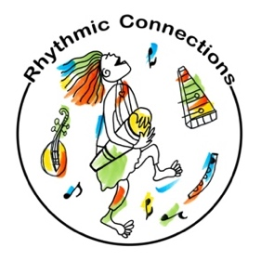
Ukulele Alive! Easy Access & Success for All Learners
TMEA conference 2023 ~ Mary Knysh (www.rhythmicconnections.com )
Slide Presentation link or QRcode

Objectives & Outline
Learn an approach to teaching ukulele that provides easy access for all styles of learners. Brain research tells us that making music, movement, creative play, and numinous experiences are key to neuroplasticity and brain-based learning. This interactive teaching method incorporates principles designed for optimal learning with the brain in mind. The sequential activities increase the level of student engagement by using rhythmic patterning, creative play, and movement as fundamental building blocks for gaining solid rhythmic, strumming, and chording skills.

Students learn two easy moveable shapes for exploration and creative play in open C tuning. These moveable shapes become the foundation for chord building in standard tuning. Movement is a key brain-based activity for chord memory and progressions. Students are invited to celebrate what they CAN do and are never left behind in the learning process. This method nurtures a “success for all” learning philosophy. Many activities include ideas for integrating Orff instruments, recorders, and boom whackers designed for classrooms with small numbers of ukuleles.

Core standards/ Skills addressed:
- Learn basic ukulele skills including strumming, picking & simple chords
- Improvise rhythmic and melodic patterns and musical ideas
- Generate musical patterns and ideas within the context of a given tonality
- Generate simple rhythmic, melodic, and harmonic phrases within AB and ABA forms
- Demonstrate selected and developed musical ideas for improvisations, arrangements, or compositions

ACTIVITY SEQUENCE OUTLINE
Success for every learner in your classroom! An INCLUSIVE approach to teaching ukulele.

3-Step Sequential Brain-Based Strategy:
DRUM ~ CHUNK ~ STRUM

MOVEMENT IS KEY TO BRAIN-BASED LEARNING
- Heartbeat to stepping pulse
- Basic Rhythmic Skills ~ Ukulele drumming
- Ukulele rhythm circle ~ explore sounds

RHYTHMIC CHUNKING
- Mute strings to create another textural sound on the uke
- Muted and open string chunking
- Expanded ukulele rhythm circle ~ building rhythmic/sound vocabulary

SLACK KEY C TUNING: FREE PLAY IMPROVISATION
- Tuning 1st string down to G
- Drumming to Strumming Techniques
- Moveable Shapes for easy access and free play

STANDARD TUNING ~ Easy Access Chord Building using Moveable Shapes
- Moveable Shape 1 to G7 chord
- G7 chord to C chord
- Moveable Shape 1 to F chord

SINGLE-STRING RHYTHM PLAY
- Open string play ~ sing what you play
- Walking the frets ~ easy introduction to chords

One & Two CHORD SONGS in Slack key C
- Row Your Boat round
- Frère Jacques arrangement: Slack Key C moveable shapes
- Monkey Song (Caribbean song)

STANDARD TUNING ~ Easy Access Chord Building using Moveable Shapes
- Moveable Shape 1 to G7 chord
- G7 chord to C chord
- Moveable Shape 1 to F chord

MOVEMENT IS KEY to Chord Progression Memory ~ brain-based approach
C (I) Center
G7 (V) Body leans Right
F (IV) Body leans Left

Two CHORD SONGS in standard tuning
- Skip to My Lou
- Jambalaya
- Tumba, Tumba (Arabic Baladi rhythm)

Three Chord Song Arrangements (drum, chunk, strum)
- 12 Bar Blues form ~ Good Morning Blues
- Reggae fun ~ Don’t Worry, Be Happy
What are your greatest challenges teaching classroom ukulele? (research for my new Uke book)
Use QRcode to answer this question & RECEIVE a thank you gift: FREE Ukulele ALIVE! lesson plans
Lesson Plans Include: Lesson Plan Outline * Chord Charts * Music Score * Play Along Tracks

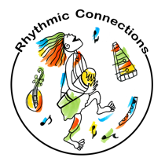

For resource materials, clinics, workshops and teacher trainings www.rhythmicconnections.com * maryknysh@gmail.com * YOUTUBE channel

Slack Key Tuning ~ Ukulele Improvisation FUN!
FREE PLAY & SPONTANEOUS COMPOSITION ~ C SLACK KEY TUNING
Easy and fun moveable shapes for creative play and improvisation

Tune your 1st string DOWN to G ~ when you strum your uke it will be a C chord
Play shape 1 (pink) and then move this shape to fret 3 & 4 (green)
Explore moving between open C and these 2 shapes
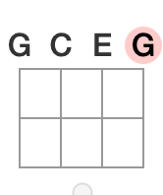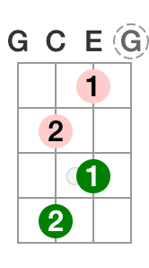
Play shape 1 (pink) with finger 1 on second string/ fret 1 and finger 2 on third string/ fret 2

Move shape 1 (green) to fret 3 & 4
SHAPE 2 ~ Keep your 2nd finger on 3rd string and slide 3rd finger onto string 2
Play this shape on fret 5 & 7

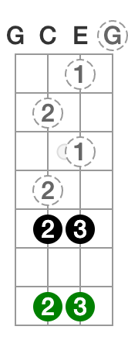

Play shape 2 on fret 5

Play shape 2 on fret 7

Slack Key Tuning ~ Ukulele Improvisation FUN!

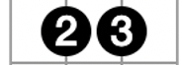
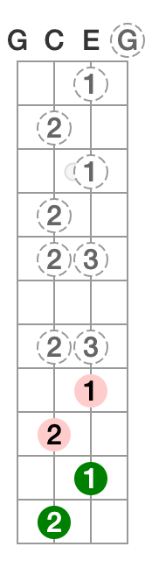
Final Shape 2 (position 3) ~ Move to fret 12

Shape 1 (position 3) ~ 2nd finger slides to fret 9, 1st finger on string 2/fret 8

Shape 1 (position 4) ~ Move to fret 10 & 11

SHAPE 2 (position 2) ~ Move to fret 7

Shape 2 (position 1) ~ Keep your 2nd finger on 3rd string and slide 3rd finger onto string 2

Shape 1 (position 1) ~ finger 1 on second string 3rd fret and finger 2 on string three on 4th fret

Shape 1 (position 2) ~ finger 1 on second string 3rd fret and finger 2 on string three on 4th fret

MONKEY Song (Caribbean) (Slack Key C tuning) C=open G7=Shape 1/Position 1
C G7 C
Every ting I do those monkeys they do, won’t you tell me what those monkeys won’t do
C G7 C
When I tap my uke they tap their uke too, won’t you tell what those monkeys won’t do

No chord Rhythm pattern No chord Repeat Rhythm pattern
When (Mary) goes (Leader: make up 8 beat pattern) Then we go (Group: repeat 8 beat pattern)
When (Mary) goes (Leader: new 8 beat pattern) Then we go (Group: repeat new 8 beat pattern)

C G7 C
Shang a lang a lang a lang a lang loo, won’t you tell me what those monkeys won’t do
C G7 C
Shang a lang a lang a lang a lang loo, won’t you tell me what those monkeys won’t do

Mama Don’t Allow ~ Boom Chuck Strum BLUEGRASS Style
C G7
Mama don’t allow no ukulele round here (no no) Mama don’t allow no ukulele round here
C F
I don’t care what Mama don’t allow Gonna play my ukulele anyhow
C G7 C
Mama don’t allow no ukulele round here

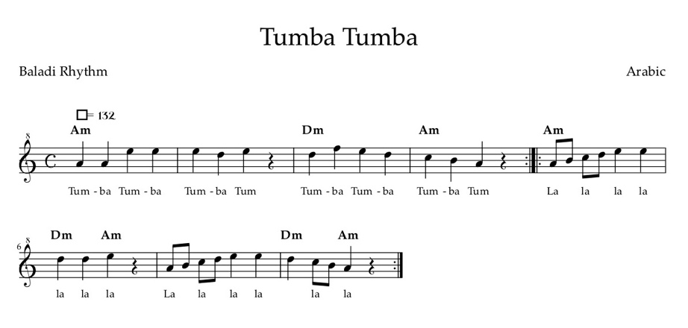

Don’t Worry Be Happy!
I love to invite students to create their own verses for this song. Use sound shapes and body conducting to integrate boomwhackers, Orff instruments and ukuleles for a dynamic and fun classroom experience.

C:C E G Dm:D F A F:F A C
Legs Shoulders Head

Progression for song (reggae feel) step tap/tap
| C | C | Dm | Dm | F | F | repeat

Ukulele BLUES in C with Walking Bass Line

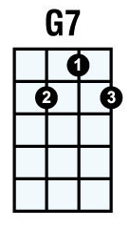
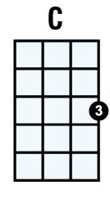
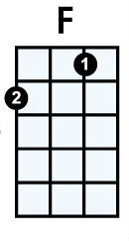

Open Open

2 2

3 3

3rd string
Open ~ 2nd ~ 3rd ~ 2nd

4th string
Open ~ 2nd ~ 3rd ~ 2nd

12 Bar Blues:
| C | C | C | C |

| F | F | C | C |

| G7 | F | C | G7 | repeat all

Good Morning Blues
C
Good Morning Blues Well, good morning blues, blues how do you do
F C7
Well, good morning blues, blues how do you do
G7 F C7 G7
I'm doing all right well, good morning how are you?

